Task 3: No of Arrest in Theft district wise

Loading the data set to a relation A and dumping it to see the result.

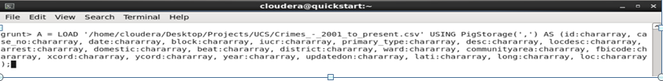

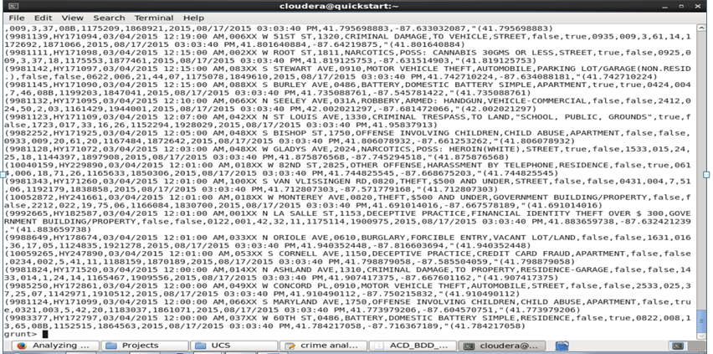

Filtering the relation A by primary_type = theft and arrest = true and dumping the relation to see the output





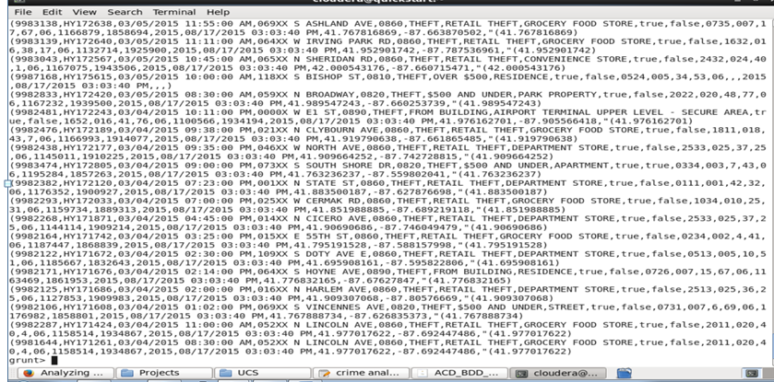

Now group B by district and storing it in the relation C





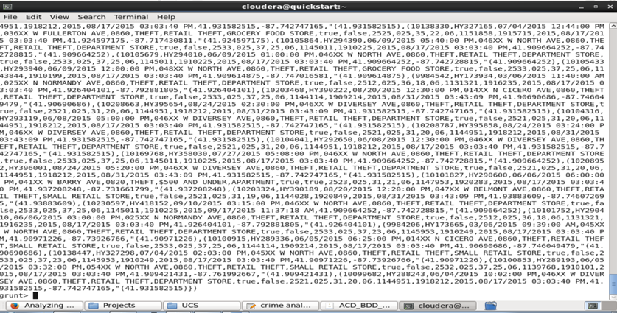

Getting the distinct record by district





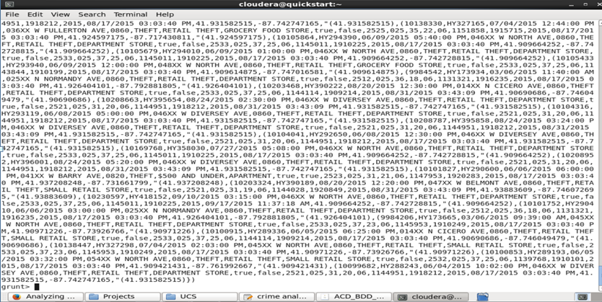

Counting the Count district wise and dumping the result.





